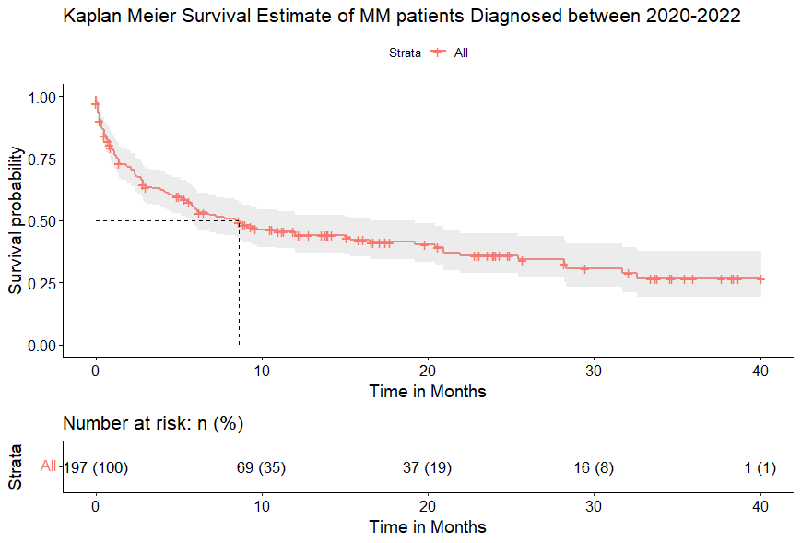**Kaplan Meier Estimate for the Overall survival of MM patients**

**Table 1: shows the median follow up time, which is 8.6 months** median

|  |
| --- |
| > summary(allfit)$table  records n.max n.start events rmean se(rmean) median 0.95LCL 0.95UCL  197.000000 197.000000 197.000000 110.000000 16.709544 1.338862 8.600000 5.700000 16.500000 |

**Table 2: Shows the 3-year survival rate which is 26.7%**

|  |
| --- |
| summary(survfit(Surv(survivalmonths, survival_status)~1, data = initial_data), times = 40.1)  Call: survfit(formula = Surv(survivalmonths, survival_status) ~ 1,  data = initial_data)  time n.risk n.event survival std.err lower 95% CI upper 95% CI  40.1 1 110 0.267 0.0469 0.19 0.377 |

**Cox Univariate Regression Output of the Covariates**

**To interpret the Cox regression Output we check at the coefficients, Z value, Hazard ratio, confidence intervals and the global statistical significance.**

1. **The coefficients**

In the coefficients we check the sign of the coefficient (coef). (+) sign indicates that the hazard (the risk of death) is higher, thus worse or poor prognosis for the group with higher values of the variable

1. **Z-value**

It gives the statistical significance. It is the Wald statistic value. The Wald statistic value is the ratio of each regression coefficient to its standard error i.e. (z = coef/se (coef)). It evaluates if the coefficients’ of a variable are statistically different from 0.

1. **Hazard ratios**

The hazard ratio is equal to the exponentiated coefficients (exp (coef) and it gives the effect size of covariates.

1. **Confidence intervals of the hazard ratios.**

The confidence intervals give the intervals of the hazard ratio.

1. **Global statistical significance of the model.**

This is given by the three p-values of the alternative tests for overall model significance.

1. **Ecog Performance**

|  |
| --- |
| summaryecog  Call:  Coxph(formula = Surv(survivalmonths, survival_status) ~ Ecog_Index,  data = initial_data)  n= 150, number of events= 89  (47 observations deleted due to missingness)  coef exp(coef) se(coef) z Pr(>|z|)  Ecog_IndexSymptomatic but ambulatory 0.3855 1.4703 0.3858 0.999 0.31772  Ecog_IndexBedridden <50% 1.2083 3.3479 0.3903 3.096 0.00196 **  Ecog_IndexBedridden >50% 1.3146 3.7233 0.4311 3.050 0.00229 **  Ecog_Indexbedridden 100% 0.8921 2.4402 1.0609 0.841 0.40041  ---  Signif. codes: 0 ‘***’ 0.001 ‘**’ 0.01 ‘*’ 0.05 ‘.’ 0.1 ‘ ’ 1  exp(coef) exp(-coef) lower .95 upper .95  Ecog_IndexSymptomatic but ambulatory 1.470 0.6801 0.6903 3.132  Ecog_IndexBedridden <50% 3.348 0.2987 1.5579 7.195  Ecog_IndexBedridden >50% 3.723 0.2686 1.5995 8.667  Ecog_Indexbedridden 100% 2.440 0.4098 0.3051 19.518  Concordance= 0.625 (se = 0.029 )  Likelihood ratio test= 19.48 on 4 df, p=6e-04  Wald test = 18.79 on 4 df, p=9e-04  Score (logrank) test = 20.17 on 4 df, p=5e-04 |
|  |

1. **CRAB Features**
2. **Hypercalcemia**

|  |
| --- |
| > summaryhypercalcemia  Call:  coxph(formula = Surv(survivalmonths, survival_status) ~ hypercalcemia,  data = initial_data)  n= 31, number of events= 18  (166 observations deleted due to missingness)  coef exp(coef) se(coef) z Pr(>|z|)  hypercalcemiaYes 0.3602 1.4336 0.4981 0.723 0.47  exp(coef) exp(-coef) lower .95 upper .95  hypercalcemiaYes 1.434 0.6976 0.5401 3.805  Concordance= 0.55 (se = 0.065 )  Likelihood ratio test= 0.53 on 1 df, p=0.5  Wald test = 0.52 on 1 df, p=0.5  Score (logrank) test = 0.53 on 1 df, p=0.5 |

1. **Renal Failure**

|  |
| --- |
| summaryrenal  Call:  coxph(formula = Surv(survivalmonths, survival_status) ~ renalfailure,  data = initial_data)  n= 129, number of events= 72  (68 observations deleted due to missingness)  coef exp(coef) se(coef) z Pr(>|z|)  renalfailure> 177 0.7591 2.1364 0.2425 3.13 0.00175 **  ---  Signif. codes: 0 ‘***’ 0.001 ‘**’ 0.01 ‘*’ 0.05 ‘.’ 0.1 ‘ ’ 1  exp(coef) exp(-coef) lower .95 upper .95  renalfailure> 177 2.136 0.4681 1.328 3.436  Concordance= 0.59 (se = 0.03 )  Likelihood ratio test= 9.31 on 1 df, p=0.002  Wald test = 9.8 on 1 df, p=0.002  Score (logrank) test = 10.24 on 1 df, p=0.001 |
|  |

1. **Anemia**

|  |
| --- |
| summaryanemia  Call:  coxph(formula = Surv(survivalmonths, survival_status) ~ anemia,  data = initial_data)  n= 156, number of events= 89  (41 observations deleted due to missingness)  coef exp(coef) se(coef) z Pr(>|z|)  anemia>=10 -0.6620 0.5158 0.2169 -3.052 0.00227 **  ---  Signif. codes: 0 ‘***’ 0.001 ‘**’ 0.01 ‘*’ 0.05 ‘.’ 0.1 ‘ ’ 1  exp(coef) exp(-coef) lower .95 upper .95  anemia>=10 0.5158 1.939 0.3372 0.7891  Concordance= 0.591 (se = 0.027 )  Likelihood ratio test= 9.37 on 1 df, p=0.002  Wald test = 9.32 on 1 df, p=0.002  Score (logrank) test = 9.63 on 1 df, p=0.002 |

1. **Bone pain**

|  |
| --- |
| summarybone  Call:  coxph(formula = Surv(survivalmonths, survival_status) ~ `Bone Pain`,  data = initial_data)  n= 197, number of events= 110  coef exp(coef) se(coef) z Pr(>|z|)  `Bone Pain`Yes -0.06168 0.94018 0.20107 -0.307 0.759  exp(coef) exp(-coef) lower .95 upper .95  `Bone Pain`Yes 0.9402 1.064 0.634 1.394  Concordance= 0.501 (se = 0.024 )  Likelihood ratio test= 0.09 on 1 df, p=0.8  Wald test = 0.09 on 1 df, p=0.8  Score (logrank) test = 0.09 on 1 df, p=0.8 |

1. **Creatinine**

|  |
| --- |
| summarycreatinine  Call:  coxph(formula = Surv(survivalmonths, survival_status) ~ creatinine,  data = initial_data)  n= 129, number of events= 72  (68 observations deleted due to missingness)  coef exp(coef) se(coef) z Pr(>|z|)  creatinine 0.0009242 1.0009247 0.0003304 2.797 0.00515 **  ---  Signif. codes: 0 ‘***’ 0.001 ‘**’ 0.01 ‘*’ 0.05 ‘.’ 0.1 ‘ ’ 1  exp(coef) exp(-coef) lower .95 upper .95  creatinine 1.001 0.9991 1 1.002  Concordance= 0.606 (se = 0.032 )  Likelihood ratio test= 6.64 on 1 df, p=0.01  Wald test = 7.83 on 1 df, p=0.005  Score (logrank) test = 8.1 on 1 df, p=0.004 |

1. **Treatment**

|  |
| --- |
| summarytrt  Call:  coxph(formula = Surv(survivalmonths, survival_status) ~ Treatment,  data = initial_data)  n= 127, number of events= 73  (70 observations deleted due to missingness)  coef exp(coef) se(coef) z Pr(>|z|)  TreatmentOthers -2.410295 0.089789 1.332517 -1.809 0.0705 .  TreatmentRadiotherapy -1.701998 0.182319 1.299581 -1.310 0.1903  TreatmentRD -5.324599 0.004870 1.363300 -3.906 9.40e-05 ***  TreatmentTD -4.660658 0.009460 0.954902 -4.881 1.06e-06 ***  TreatmentVCD -5.207935 0.005473 1.081484 -4.816 1.47e-06 ***  TreatmentVD -4.865249 0.007710 1.159392 -4.196 2.71e-05 ***  TreatmentVRD -4.642853 0.009630 0.965765 -4.807 1.53e-06 ***  TreatmentVTD -4.516940 0.010922 0.928025 -4.867 1.13e-06 ***  ---  Signif. codes: 0 ‘***’ 0.001 ‘**’ 0.01 ‘*’ 0.05 ‘.’ 0.1 ‘ ’ 1  exp(coef) exp(-coef) lower .95 upper .95  TreatmentOthers 0.089789 11.137 0.0065915 1.22310  TreatmentRadiotherapy 0.182319 5.485 0.0142767 2.32829  TreatmentRD 0.004870 205.326 0.0003366 0.07047  TreatmentTD 0.009460 105.706 0.0014558 0.06148  TreatmentVCD 0.005473 182.716 0.0006571 0.04558  TreatmentVD 0.007710 129.703 0.0007946 0.07480  TreatmentVRD 0.009630 103.840 0.0014507 0.06393  TreatmentVTD 0.010922 91.555 0.0017717 0.06734  Concordance= 0.565 (se = 0.038 )  Likelihood ratio test= 21.34 on 8 df, p=0.006  Wald test = 33.48 on 8 df, p=5e-05  Score (logrank) test = 112.9 on 8 df, p=<2e-16 |
|  |

**Multivariate Cox Regression**

A multivariate cox regression is only fit for covariates that are significant during univariate cox regression.

|  |
| --- |
| > summary(mm.cox)  Call:  coxph(formula = Surv(survivalmonths, survival_status) ~ Ecog_Index +  creatinine + Treatment + anemia + renalfailure, data = initial_data)  n= 74, number of events= 42  (123 observations deleted due to missingness)  coef exp(coef) se(coef) z Pr(>|z|)  Ecog_IndexSymptomatic but ambulatory -0.1052366 0.9001116 0.7191780 -0.146 0.8837  Ecog_IndexBedridden <50% 1.0893796 2.9724294 0.7011660 1.554 0.1203  Ecog_IndexBedridden >50% 1.0055126 2.7333079 0.7447155 1.350 0.1770  Ecog_Indexbedridden 100% NA NA 0.0000000 NA NA  creatinine 0.0004824 1.0004826 0.0010545 0.458 0.6473  TreatmentTD -2.4317006 0.0878872 1.2223831 -1.989 0.0467 *  TreatmentVCD -3.3592242 0.0347622 1.3896836 -2.417 0.0156 *  TreatmentVD -1.9321184 0.1448410 1.6647466 -1.161 0.2458  TreatmentVRD -2.7497763 0.0639422 1.2299671 -2.236 0.0254 *  TreatmentVTD -2.3316817 0.0971323 1.1800171 -1.976 0.0482 *  anemia>=10 -0.1743423 0.8400093 0.3829924 -0.455 0.6490  renalfailure> 177 0.1425972 1.1532652 0.5363373 0.266 0.7903  ---  Signif. codes: 0 ‘***’ 0.001 ‘**’ 0.01 ‘*’ 0.05 ‘.’ 0.1 ‘ ’ 1  exp(coef) exp(-coef) lower .95 upper .95  Ecog_IndexSymptomatic but ambulatory 0.90011 1.1110 0.219852 3.6852  Ecog_IndexBedridden <50% 2.97243 0.3364 0.752104 11.7475  Ecog_IndexBedridden >50% 2.73331 0.3659 0.635017 11.7650  Ecog_Indexbedridden 100% NA NA NA NA  creatinine 1.00048 0.9995 0.998417 1.0026  TreatmentTD 0.08789 11.3782 0.008006 0.9648  TreatmentVCD 0.03476 28.7669 0.002281 0.5297  TreatmentVD 0.14484 6.9041 0.005544 3.7838  TreatmentVRD 0.06394 15.6391 0.005739 0.7124  TreatmentVTD 0.09713 10.2952 0.009615 0.9813  anemia>=10 0.84001 1.1905 0.396534 1.7795  renalfailure> 177 1.15327 0.8671 0.403086 3.2996  Concordance= 0.695 (se = 0.043 )  Likelihood ratio test= 21.13 on 11 df, p=0.03  Wald test = 20.03 on 11 df, p=0.04  Score (logrank) test = 23.58 on 11 df, p=0.01 |
|  |
| |  | | --- | |  | |

**Testing if the cox regression assumptions are met**

|  |
| --- |
| > test.phmm  chisq df p  Ecog_Index 2.272 3 0.52  creatinine 0.160 1 0.69  Treatment 8.980 5 0.11  anemia 0.312 1 0.58  renalfailure 1.066 1 0.30  GLOBAL 14.545 11 0.20 |

**Graphs of the scaled Schoenfeld residuals against the transformed time**

